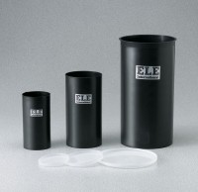 | Plastic Lid for 6" dia Mould  Code: 34-5294/10  Product Group: Plastic Cylinder Moulds  (152 mm) diam. Moulds. Carton of 50.

Standards
ASTM C39, ASTM C470, AASHTO M205

