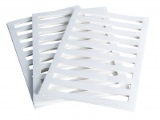 | Filter Paper Drain 100mm/4 Inch Diameter. Pack of 50.  Code: 25-7670  Product Group: Filter Paper Drains, Accessories for CU/CU effective stress  Filter paper drain 100 mm diameter (Pack Of 50).

Standards
ASTM D2850, ASTM D4767, ASTM D7181, AASHTO T296, AASHTO T297

