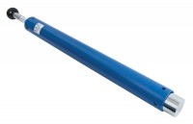 | ASTM Compaction Rammer 4.5Kg.  Code: 24-9070  Product Group: Modified Compaction Hammer, ASTM/Modified Proctor compaction  50.8mm diameter x 457mm drop.

Standards
ASTM D1557, AASHTO T180

Specification
Rammer | 2 in dia, 10 lb
Drop | 18 in
Guide Sleeve | Machined steel tubing with air pressure release holes
Finish | Corrosion resistant
Weight kg | 6.3
Hammer | 2” diam. (50.8 mm); 10 lbs. (4.5 kg).
Drop | 18” (45 7 mm).
Guide Sleeve | Machined steel tubing with integrally spun end cap; air  pressure release holes.
Weight | Net 14 lbs. (6.3 kg).

