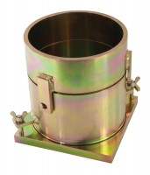 | ASTM Compaction Mould 152mm.  Code: 24-9066  Product Group: ASTM/Modified Proctor compaction, Accessories for ASTM and Proctor compaction  152mm inside diameter

Standards
ASTM D698, ASTM D1557, AASHTO T99, AASHTO T180

Specification
Dimensions | 152.4 mm dia x 116.4 mm high
Rammer Mould Volume | 1/13.33 ft³
Construction | All steel, threaded studs with wing nuts, plated.
Weight | 8.2 kg

