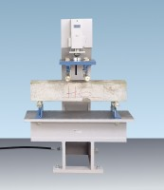 | 100kN Flexural and Transverse (Flags) Frame. Supplied Without Specimen Bearers and Fitting Kit.  Code: 37-6140  Product Group: Flexural and Transverse Testing  • Open sided for ease of specimen loading  • Meets EN 1339, 1340 for kerbs and flagstones  • Optional ball seating assembly  This rigidly constructed, open sided frame is suitable for testing kerbs and flagstones to EN 1339,1340. With optional accessories it can also be used to test 100 mm and 150 mm section beams for flexural strength to EN 12390-5.  The frame supports a hydraulic ram and upper subplaten assembly incorporating spherical seating. The upper and lower sub-platens will accept specimen loading bearers, which are supplied separately.

Further Information
**Not available for sale in the USA**

