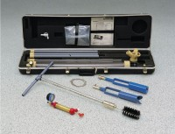 | Permeameter Extension Kit  Code: 25-0655  Product Group: Guelph Permeameter  31-1/2” (800 mm) long. Increases test depth to 155 cm (5.16 ft).

Standards
ASTM D5126

