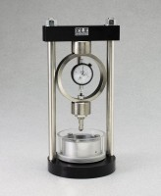 | Soil Moisture Change Meter  Code: 25-0390  Product Group: Soil Volume Change Meter

Specification
Mould Assembly | Includes porous stones and loading cap.
Proving Ring | 1,000 lb. (4.5 kN) capacity; dial indicator.
Other Components | Loading pistons; compaction hammer.
Specimen Ring | 2-3/4â (70 mm) diam.
Water Required | 5 oz.
Charts | Convert readings to lbs./sq. ft. and then to PVC (Potential Volume Change) rating.
Dimensions | 7-1/4â diam. base x 15 -1/2â h. (184 x 394 mm).
Weight | Net 25 lbs. (11 .3 kg).

Spares/Consumables
 | Porous Stone 2.74" x 0.4"  Code: 9417-0001
Porous Stone 3.0" x 5"
Code: 9417-0006

