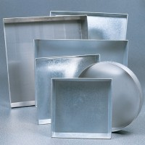 | Sample Tray - 610 x 610 x 63 mm  Code: 81-4080  Product Group: Sample Trays

Further Information
**NOT AVAILABLE FOR SALE IN THE USA**

