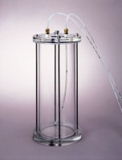 | Tri-Flex 2 Water De-airing Tank System  Code: 25-0698  Product Group: Tri-Flex 2 Auxiliary Control Panel, Tri-Flex 2 Master Control Panel, Tri-Flex 2 Water De-Airing Tank System, Tri-Flex 2 One-Cell Permeability Test System

Standards
ASTM D2850, ASTM D4767, ASTM D7181, ASTM D5084, AASHTO T296, AASHTO T297

Specification
Construction | Clear acrylic construction with stainless steel threaded clamping rods.
Seals | O-ring, top & bottom.
Relief Valve | Preset at 10 psi (69 kPa).
Capacity | 1.4 gals. (5.3 litres).
Dimensions | 6â diam. x 16â (152 .4 x 406.4 mm).
Weight | Net 7.5 lbs. (3.4 kg).

