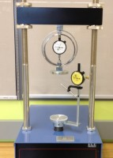 | Unconfined Compression Test Accessory Set, Metric  Code: 25-3998  Product Group: Versa-Loader  Includes: platens, 25 mm range dial indicator and 2.2 kN capacity proving ring.

Standards
ASTM D2166, AASHTO T208

