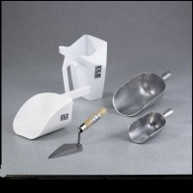 | Trowel  Code: 88-7400  Product Group: Trowel  2-1/2” w. x 4-1/2” l. (63.5 x 114 mm) blade.

Specification
Handles | Wood.
Blades | Steel plated; triangular.

