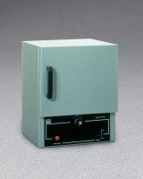 | Double Wall Laboratory - 3.0 cu. Ft. Capacity - 230vAC  Code: 88-0220/01  Product Group: Double Wall Laboratory Ovens  230vAC, 50/60 Hz, 1ø.

Specification
Capacity | 3.0 cu. ft. (85 liter).
Chamber Size | 18â w. x 14 â d. x 21 â h. (45 7 x 35 6 x 533 mm).
Temperature Range | 228 Â°C (43 7Â°F) maximum.
Shelves | Two included.
Thermometer | One included.
Overall Dimensions | 20â w. x 16â d. x 30â h.  (508 x 406 x 762 mm).
Weights | 90 lbs. (40.8 kg).

