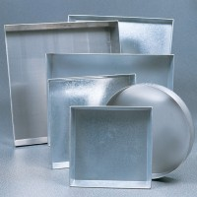 | Sample Tray - 1200 x 1160 x 50 mm  Code: 81-4230  Product Group: Sample Trays

Further Information
**NOT AVAILABLE FOR SALE IN THE USA**

