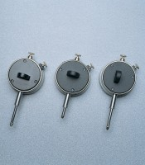 | Dial Gauge  Code: 83-5451  Product Group: Dial Gauges

Specification
Diameter mm | 57
Travel mm | 10
Grad. Mm | 0.002
Scale | RH
Anvil | None
Back type | B

