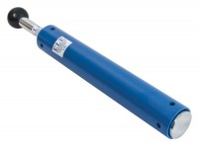 | ASTM Compaction Rammer 2.5Kg.  Code: 24-9063  Product Group: Standard Compaction Hammer, Proctor compaction  50.8mm diameter x 305mm deep.

Standards
ASTM D558, ASTM D559, ASTM D560, ASTM D698, AASHTO T99, AASHTO T134, AASHTO T135, AASHTO T136

Specification
Rammer | 2 in dia, 5.5 lb
Drop | 12 in
Guide Sleeve | Machined steel tubing with air pressure release holes
Finish | Corrosion resistant
Weight kg | 4.1
Hammer | 2” diam. (50.8 mm); 5-1/2 lbs. (2.49 kg).
Drop | 12 ” (305 mm).
Guide Sleeve | Machined steel tubing with integrally spun end cap; air pressure release holes.
Weight | Net 9 lbs. (4.1 kg).

