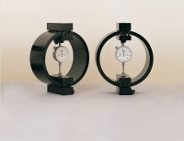 | Clamped Boss Load Ring - 3.0 kN  Code: 78-0160  Product Group: Clamped Boss Load Rings, Digital Tritest 50 Load Frame, Direct/Residual Shear Apparatus, Proving Rings, Measurement of Load (Shear Stress)

Standards
BS 1377, ASTM D3080

Specification
Capacity: kN, kgf, lbf | 3.0, 300, 650
Typical Design sensitivity: N/div, kgf/div, lbf/div | 2.0, 0.20, 0.43
Overall height mm | 248
Approx weight kg | 3.3
Capacity - lbf | 1,000
Capacity - kN | 3
Capacity - kgf | 300
Typical Design Sensitivity - lbf/div | 0.43
Typical Design Sensitivity - kN/div | 2
Typical Design Sensitivity - Kgf/div | 0.2
Overall Height | 9.76” (248 mm)
Approx Weight | 7.3 lbs.(3.3 kg)

Spares/Consumables
 | Spare Dial Indicator for Load Rings  Code: 78-5461

