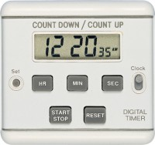 | Timer Clock  Code: 81-0518  Product Group: Rice Test Vibrator, Watches and Clocks  Accessory

Standards
EN 12697-5

Further Information
**NOT AVAILABLE FOR SALE IN THE USA**

Spares/Consumables
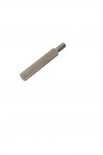 | Consistency Plunger  Code: 38-2010/10

