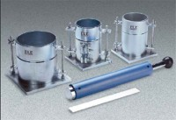 | Standard Compaction Mould  Code: 24-9097  Product Group: Standard Compaction Mould, Automatic Soil Compactor  1/30 cu.ft.; 4” i.d. x 4.584” h.

Standards
ASTM D558, ASTM D559, ASTM D560, ASTM D698, ASTM D1557, AASHTO T99, AASHTO T134, AASHTO T135, AASHTO T136, AASHTO T180

Specification
Mould Volume | 1/30 cu. ft.
Dimensions | 4â i.d. x 4.584â h. (101.6 x 11 6.4 mm).
Base Plate | 6â x 6â x 1/2â thick (152 x 152 x 13 mm).
Weight | Net 12 lbs. (5.4 kg).

