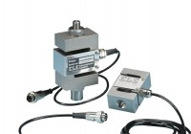 | 50kN S-type Load Cell  Code: 27-1559  Product Group: Force measurement, Load Measurement, Electronic Instrumentation  Maximum working capacity of 50 kN and excitation 10 V ac/dc with an output of 2.7 mV/V nominal. Aluminium alloy and stainless steel construction with IP65 environmental protection.

Standards
EN 12697-34

Further Information
**NOT AVAILABLE FOR SALE IN THE USA**

