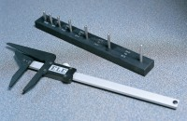 | 3.1 Shape Index Caliper.  Code: 42-0821  Product Group: Determination of the Shape Index  Designed to measure the ratio of length to width of individual aggregate particles.

Standards
EN 933-4

Further Information
**NOT AVAILABLE FOR SALE IN THE USA**

