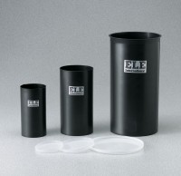 | Plastic Cylinder Mould 4" x 8"  Code: 34-5292  Product Group: Plastic Cylinder Moulds  (102 x 203 mm). Carton of 36.

Standards
ASTM C39, ASTM C470, AASHTO M205

Specification
Construction | Single unit molded polypropylene
Inner Dimensions | 4" diam x 8" h (102 x 203 mm)
Weights | Net 13 lbs (5.9 kg)

