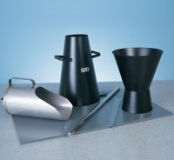 | Slump Test Set BS & ASTM. C/W Slump Cone Base Plate Steel Rule Tamping Rod & Funnel.  Code: 34-0192  Product Group: Slump Test  BS and ASTM comprising of slump cone, base plate, steel rule, tamping rod and funnel.

Further Information
**NOT AVAILABLE FOR SALE IN THE USA**

