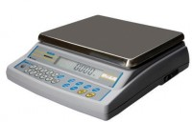 | Electronic Balance - 450 g x 0.001 g  Code: 78-5405/01  Product Group: Electronic Balances

Further Information
**Not available for sale in the USA**

Specification
Capacity resolution | 450 g x 0.001 g
Pan size | 125 x 125 mm
Mains and battery | No
Dimensions (l x w x h) | 300 x 205 x 90 mm
Weight | 6 kg

