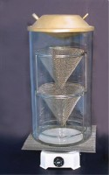 | Replacement bowl for Rotatest 1500 centrifuge extractor  Code: 45-3810/10  Product Group: Asphalt Centrifuge Extractors  Holds 1500 g

Standards
EN 12697-1, ASTM D2172, AASHTO T164

Further Information
**NOT AVAILABLE FOR SALE IN THE USA**

