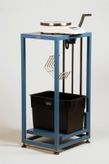 | Buoyancy Balance  Code: 34-8100/09  Product Group: Hardened Concrete - Buoyancy Balance, Percentage Refusal Density (PRD)

Standards
EN 12697-32, EN 13280-4, BS 598-104

Further Information
**NOT AVAILABLE FOR SALE IN THE USA**

