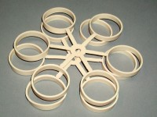 | Soil Sample Retaining Rings Pack of 12.  Code: 532-108  Product Group: Pressure plate extractors

