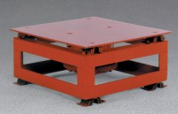 | Vibrating Table  Code: 34-6222/02  Product Group: Vibrating Table  Control panel included, but not shown

Further Information
115vAC, 60 Hz, 1ø. 100 Watts.

Specification
Capacity | Up to 300 lbs (136 kg)
Deck | Cushioned steel; 20" w x 20" d (508 x 508 mm)
Vibrator | High-speed 3,600 vpm; electromagnetic
Control panel | Separate; includes operating switch, fuse, rectifying element and amplitude control dial.
Amplitude | Variable from 0 to 1/16â (1.58 mm) linear vibration.
Dimensions | 20â w. x 20â d. x 10â h. (508 x 508 x 254 mm).
Weight | Net 175 lbs. (79 kg); Shpg. 200 lbs. (91 kg).

