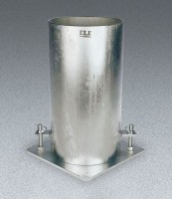 | Heavy-Duty Cylinder Mould 6" x 12"  Code: 34-5280  Product Group: Heavy-Duty Cylinder Moulds  (152 x 305 mm) samples.

Standards
ASTM C39, ASTM C192, AASHTO T23, ASTM T126

Specification
Base Attachment | 2 forged steel stud-and-clip assemblies welded to mold.
Mold Closure | 2 forged steel clamps welded to mold along longitudinal split.
Wall Thickness | 1/4" (6.3 mm)
Base Dimensions | 8" x 8" x 1/4" thick (203 x 203 x 6.3 mm)
Optimum Pouring Range | 260Â°-290Â°F (12 6Â°-143 Â°C).
Weight | Net 50 lbs. (22 .7 kg); Shpg. 52 lbs. (23 .6 kg).

