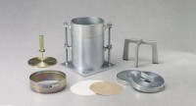 | Circular Surcharge Weight 10 lb  Code: 24-9247  Product Group: Surcharge Weights  10” o.d. (254 mm).

Specification
Construction | Machined steel.
Finish | Plated.

