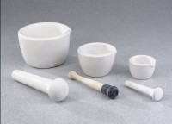 | Mortar & Pestle - 650 ml Capacity, 9" Length  Code: 88-6804  Product Group: Mortars and Pestles  Mortar 7-1/4” (184 mm) diam. x 3-3/4” (95 mm) h. 9” (229 mm) long pestle.

Specification
Material | Porcelain.
Weight | Net 6 lbs. (2.7 kg).

