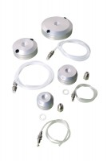 | Pressure Pad 50mm Diameter.  Code: 25-5430  Product Group: Specimen Caps, Pressure Pads  50 mm diameter pressure pad. The pad shall have two empty ports and will come complete with two blanking plugs, plastic tubing and connector. Suitable For both drained and undrained tests.

