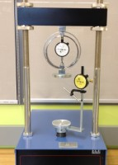 | Unconfined Compression Test Accessory Set, English  Code: 25-3997  Product Group: Versa-Loader  Includes: platens, 1.0" range dial indicator and 500 lb. capacity proving ring.

Standards
ASTM D2166, AASHTO T208

