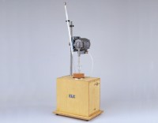 | Heat of Hydration Apparatus  Code: 38-4600/06  Product Group: N/A  For 220 – 240 V AC, 60 Hz, 1 ph.

Standards
BS 4550

Spares/Consumables
 | Beckman Thermometer and Reader Glass  Code: 38-4600/12
Dewar Flask
Code: 38-4600/10
Glass Paddle for Stirrer
Code: 38-4600/13

