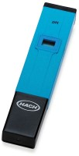 | Lightweight pH Tester  Code: 88-2010  Product Group: Lightweight pH Tester

Specification
Range | 0.00 to 14 .00 pH.
Resolution | 0.01 pH.
Accuracy | Â± 0.2 pH.
Calibration | Two point through offset and slope trimmers.
Environment | 0Â°C to 50Â°C (32 Â°F to 122 Â°F); 95% RH.
Battery Type | 2 x 1.4 Volts.
Battery Life | 3,000 hours of continuous use.
Dimensions | 66 x 50 x 25 mm (2.6â x 2.0â x 1â).
Weight | Net 63g (2.2 oz.).

