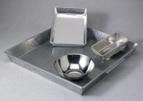 | Mixing Pan - Round Stainless - 9" x 4"  Code: 88-7180  Product Group: Mixing Pans and Bowls  Stainless steel; 9” diam. x 4” (229 x 102 mm).

