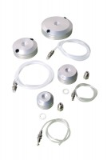 | Pressure Pad 100mm Diameter.  Code: 25-7590  Product Group: Specimen Caps, Pressure Pads  100 mm diameter pressure pad. The pad shall have two empty ports and will come complete with two blanking plugs, plastic tubing and connector. Suitable For both drained and undrained tests.

Standards
ASTM D2850, ASTM D4767, ASTM D7181, AASHTO T296, AASHTO T297

