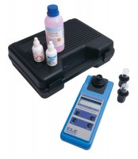 | Dissolved Oxygen / Temp Meter. with Electrode and Carrying Case  Code: 521-050  Product Group: Paqualab Test Meters

