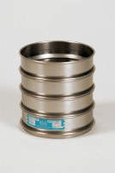 | 12in Dia ASTM Sieve 2.80mm Stainless Steel Mesh.  Code: 79-5850  Product Group: 12" Diameter ASTM Sieves, 12" Diameter ASTM Sieves, 12" Diameter ASTM Sieves

Standards
ASTM E11

Further Information
**NOT AVAILABLE FOR SALE IN THE USA**

