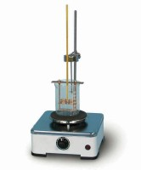 | BS/EN Ring and Ball Apparatus  Code: 46-4605  Product Group: Ring and Ball Apparatus  With 2 shouldered pattern rings, 2 ball-centring guides and 2 balls. The apparatus has a support frame and is retained in a heat resistant container.

Standards
EN 1427, BS 2000-58

Further Information
**NOT AVAILABLE FOR SALE IN THE USA**

