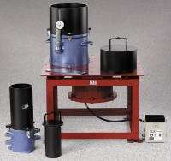 | Vibrating Table 60 Hz  Code: 24-9112/06  Product Group: Vibrating Tables

Standards
ASTM D4253, ASTM D4254

Further Information
220vAC, 60 Hz, 1ø.

Specification
Table | Steel construction; 30â x 30â (762 x 762 mm)  cushioned steel deck.
Actuator | Electromagnetic vibrator; semi-noiseless;  over 100 lb. (45 .3 kg) net wt.
Frequency | 3,600 vpm; variable amplitude separately  controlled.
Table Capacity | 750 lbs. (34 0 kg).
Double Amplitude Range | 0.002â to 0.015 â (0.05 to 0.38 mm).
Dimensions | 30â w. x 30â d. x 21 â h. (762 x 762 x 533 mm).
Weight | Net 555 lbs. (252 kg); Shpg. 605 lbs. (274 kg).

