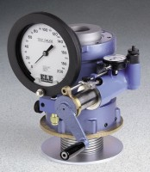 | Hveem Stabilometer - ASTM Type  Code: 45-7500  Product Group: Hveem Stabilometer  ASTM Type. Includes displacement dial indicator, diaphragm tester with polyurethane dummy specimen, two followers, rubber bulb, extra O-rings, 1 qt. of oil, wrench, assembly tool and instructions.

Standards
ASTM D1560, ASTM D2844, AASHTO T190, AASHTO T246

Specification
Specimen Size | 4â (101.6 mm) diam.
Gauge | 200 psi capacity; 1/4% accuracy.
Loading | Diaphragm/piston pump.
Shell | Aluminum-Magnesium; adjustable stage.
Pressure Fluid | 1 qt. hydraulic fluid (included).
Dial Indicator | 1.0â displacement x 0.001â divisions.
Followers | Two included; one 3.985â Â± 0.005â diam.  x 5-1/2â; one 3.95â Â± 0.005â diam. x 5â h.
Weight | Net 55 lbs. (24.9 kg).

Spares/Consumables
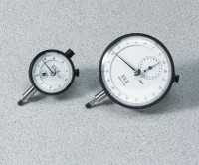 | Dial Indicator - 1.0" Range  Code: 88-4100
 | Diaphragms  Code: 45-7500/12
Hveem Test Block
Code: 45-7500/10

