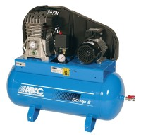 | Air Compressor  Code: 83-1735/01  Product Group: Air Compressors, Air/Water Pressure Systems - up to 1000 kPa

Specification
Dimensions (l x w x h) | 1321 x 457 x 914 mm
Free air delivery | 6.0 cfm
Receiver capacity | 116 litres
Maximum pressure | 1380 kPa
Continuous working pressure | 1000 kPa
Electrical supply | 221 â 240 V AC  1 ph 50 Hz
Water Trap | Yes
Weight | 149 kg

