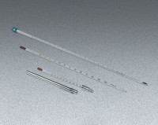 | Glass Laboratory Thermometer - 20° to 500°F x 2.0°; 16” (406 mm) l.  Code: 88-4498  Product Group: Glass Laboratory Thermometers

