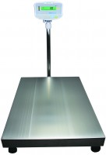 | Electronic Balance - 75 000 g x 5.0 g  Code: 78-5655/01  Product Group: Electronic Balances

Further Information
**Not available for sale in the USA**

Specification
Maximum Capacity | 75 kg
Pan size | 425 x 525 mm
Mains and battery | Yes
Dimensions (l x w x h) | 700 x 425 x 950 mm
Weight | 28 kg

