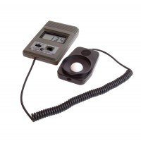 | Light Measuring Unit (Luxmeter) with Sensor.  Code: 505-106  Product Group: Light measurement  • Direct readout in energy units of visible light.  • Range 0 - 200 K Lux in 3 ranges of sensitivity.  •Use for siting of buildings, measuring light variations.  General measurement for human activities.  The visible light is that part of the wavelength spectrum received by the human eye. The peak sensitivity is 555 nm for the adapted eye but with "dark adaption" a peak response is 507 nm. The ranges allow for readings between 0 - 200 K Lux.  The sensor has a cosine-corrected head, and the FET input circuitry of the cc measuring and display unit, preserves lineariry. The unit also incorporates dual slope integration with "auto zero" for A/D conversion.

Further Information
With sensor and 1.2 m cable. Supplied in carrying case with battery.

