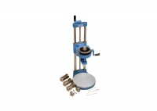 | Laboratory Vane Apparatus with 4 Springs and 12.7mm Vane; Hand Operated.  Code: 26-2270  Product Group: Laboratory Vane Apparatus, Laboratory Vane Apparatus  The equipment is based on a design by the Transport Research Laboratory, England, and is available in hand or motorised versions. Stress is applied through the 12.7 x 12.7 mm vane by means of any one of four calibrated springs.

Standards
BS 1377

Further Information
Hand-operated, complete with 4 calibrated springs and a 12.7 mm diameter x 12.7 mm long vane.

Spares/Consumables
 | Set of 4 Calibrated Springs for Laboratory Vane Apparatus.  Code: 26-2275/10

