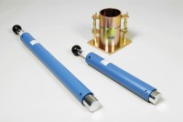 | BS Standard Compaction Mould 1000Cm Capacity.  Code: 24-9000  Product Group: BS/EN compaction test 2.5kg, Accessories for BS compaction and CBR  Plated steel standard compaction mould to BS 1377, comprising of a collar mould body and base plate with quick release wing nuts for easy dismantling.

Standards
BS 1377-4, BS 1924-2, EN 1997-2

Specification
Mould volume | 1 litre
Dimensions | 105 mm dia x 115.4 mm high
Construction | All steel, threaded studs with wing nuts, plated.
Weight | 5.5 kg

