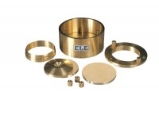 | Consolidation Cell Complete 75mm Diameter Sample  Code: 25-0503  Product Group: BS EN consolidation cells and accessories, Pneumatic Consolidation Apparatus, Fixed Ring Consolidation, Table Top Consolidation Apparatus

Standards
BS 1377, EN 1997-2

Specification
Application | BS/EN 10:1
Specimen Dia | 75 mm
Specimen area | 4418 mm²
Beam ratio | 9:1
Load kg | 1
Stress | 20 kPa
Typical max stress | 3.2 MPa
Stress for 1 kg m² | 20 kPa
Application | BS
Specimen Diameter | 75 mm
Specimen Area | 4418 mm²
Beam Ratio | 10:01
Load | 1 kg
Stress | 20 kPa
Typical Maximum Stress | 3.2 MPa
Stress for 1 kg | 20 kPa

Spares/Consumables
75mm Dia Upper and Lower Porous Stones for Use on EL25-0503 Series Cell.
Code: 25-0503/13
Cutting Ring 75mm Cell.
Code: 25-0506

