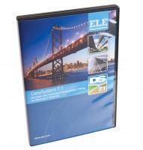 | DS7.1 Permeability in a Triaxial Cell Program for Windows 7, 32/64 bit  Code: 27-1767  Product Group: N/A  This program provides data for the determination of permeability of soil specimens using a triaxial cell and two volume change units in accordance with BS 1377.

