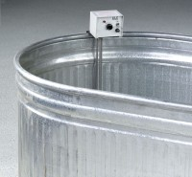 | Concrete Curing Tank  Code: 34-6764  Product Group: Concrete Curing Tanks  300 Gal. capacity

Specification
Construction | 20-gage sides with 20-gage bottom with zinc coating; rolled top for added stiffness; drain plug.
Dimensions | 96" l. x 36" w. x 24" d. (2,438 x 914 x 610 mm).
Weights. | Net 130 lbs. (59 kg).

